**Experiment 2.2**

**Student Name:** Nabha Varshney **UID:** 20BCS4995

**Branch:** B.E.-CSE  **Section/Group:** 20BCS704-A

**Semester:** 6th **Date of Performance:** 04/04/2023

**Subject Name:** Internet of Things Lab **Subject Code:** 20CSP-358

1. **Aim:**

#### Interfacing of Arduino/Raspberry Pi with temperature and humidity sensor with real time application.

1. **Objective:**

* Learn about interfacing.
* Learn about IoT programming.

1. **Requirements:**

* Raspberry Pi3 Model B`s with installed Raspbian or Arduino Board
* 8 GB microSD cards
* Internet connection (Wired or Wireless) to access Pi Desktop
* VNC client on a wired or wireless device
* Breadboard
* Jumper Wires
* DH11 Temperature and Humidity Sensor
* USB or 5V Power Supply

1. **Procedure:**

#### **About DH11 Sensor:**

DHT11 Module features a temperature & humidity sensor complex with a calibrated digital signal output. The exclusive digital-signal-acquisition technique and temperature & humidity sensing technology ensure high reliability and excellent long-term stability. This sensor includes an NTC for temperature measurement and a resistive-type humidity measurement component for humidity measurement. These are connected to a high-performance 8-bit microcontroller, offering excellent quality, fast response, anti-interference ability, and cost-effectiveness.

### ***DHT11 Module Pinout***

The DHT11 module has a total of 3 pins. In which two are for power and one is for communication. The pinout of a DHT11 Sensor module is as follows:

* DATA Data pin for 1-wire communication.
* GND Ground Connected to Ground pin of the Arduino.
* VCC Provides power for the module, Connect to the 5V pin of the Arduino.

### ***DHT11 Module Parts***

The DHT11 module has only a very low number of parts that includes the DHT11, pullup resistor, bypass capacitor, and power led with a current limiting resistor.

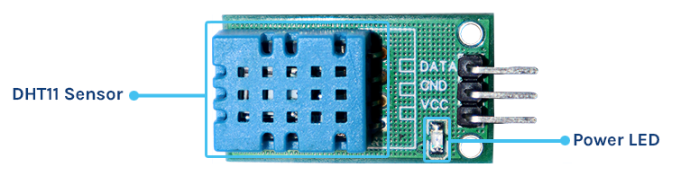

The following image shows the circuit diagram for interfacing the DHT11 sensor module with Arduino.

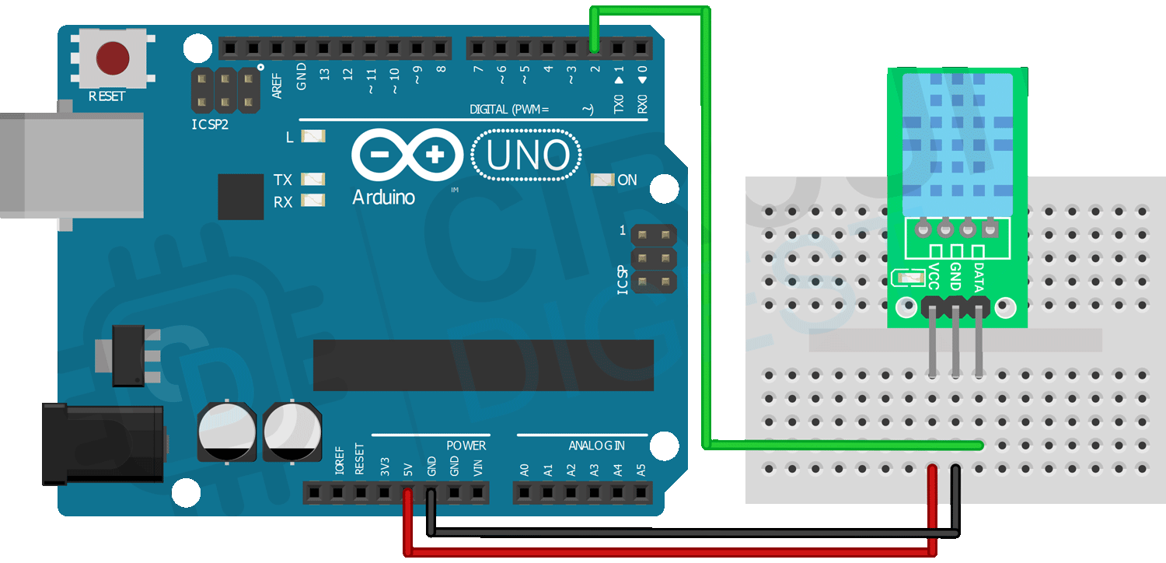

1. **Code/Program:**

#include <DHT.h>

dht DHT;

#define DHT11_PIN 7

#define tone_PIN 8

void setup()

{

Serial.begin(9600);

}

void loop()

{

int chk=DHT.read11(DHT11_PIN);

Serial.print("Temperature: ");

Serial.print(DHT.temperature);

Serial.print("Humidity: ");

Serial.print(DHT.humidity);

delay(1000);

if(DHT.temperature>=30)

{

tone(8,1000);

delay(1000);

}

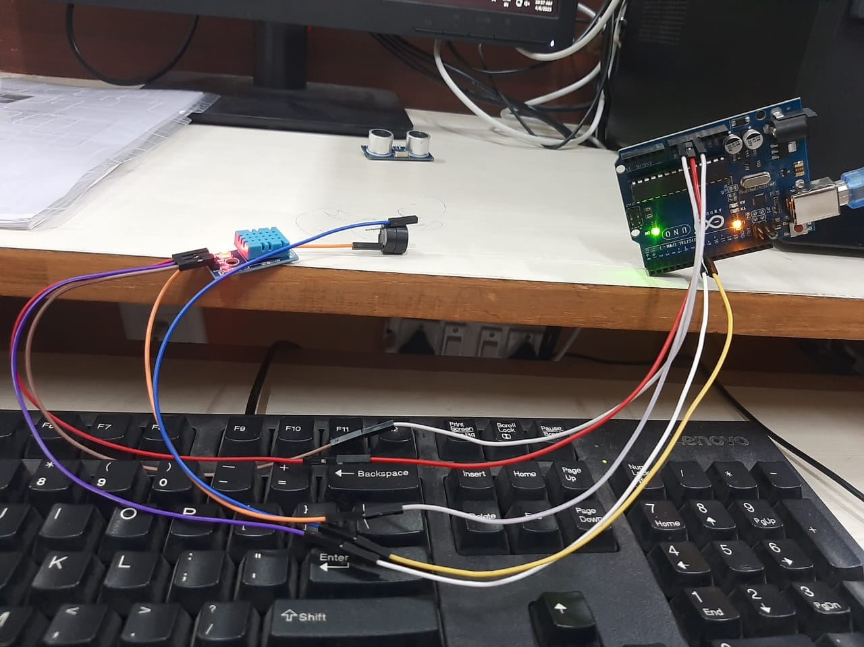}

**FIGURE: CIRCUIT**

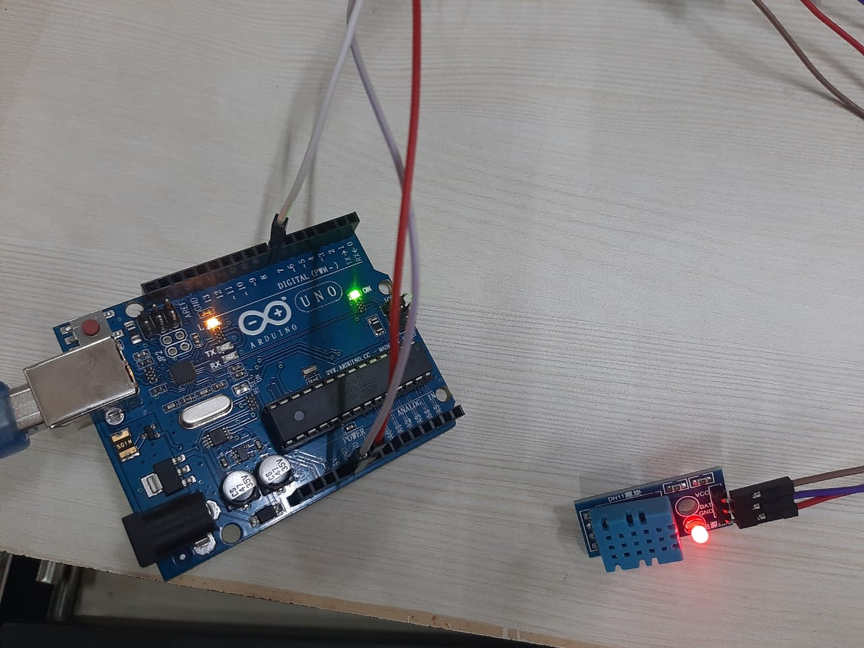

**FIGURE: CIRCUIT**

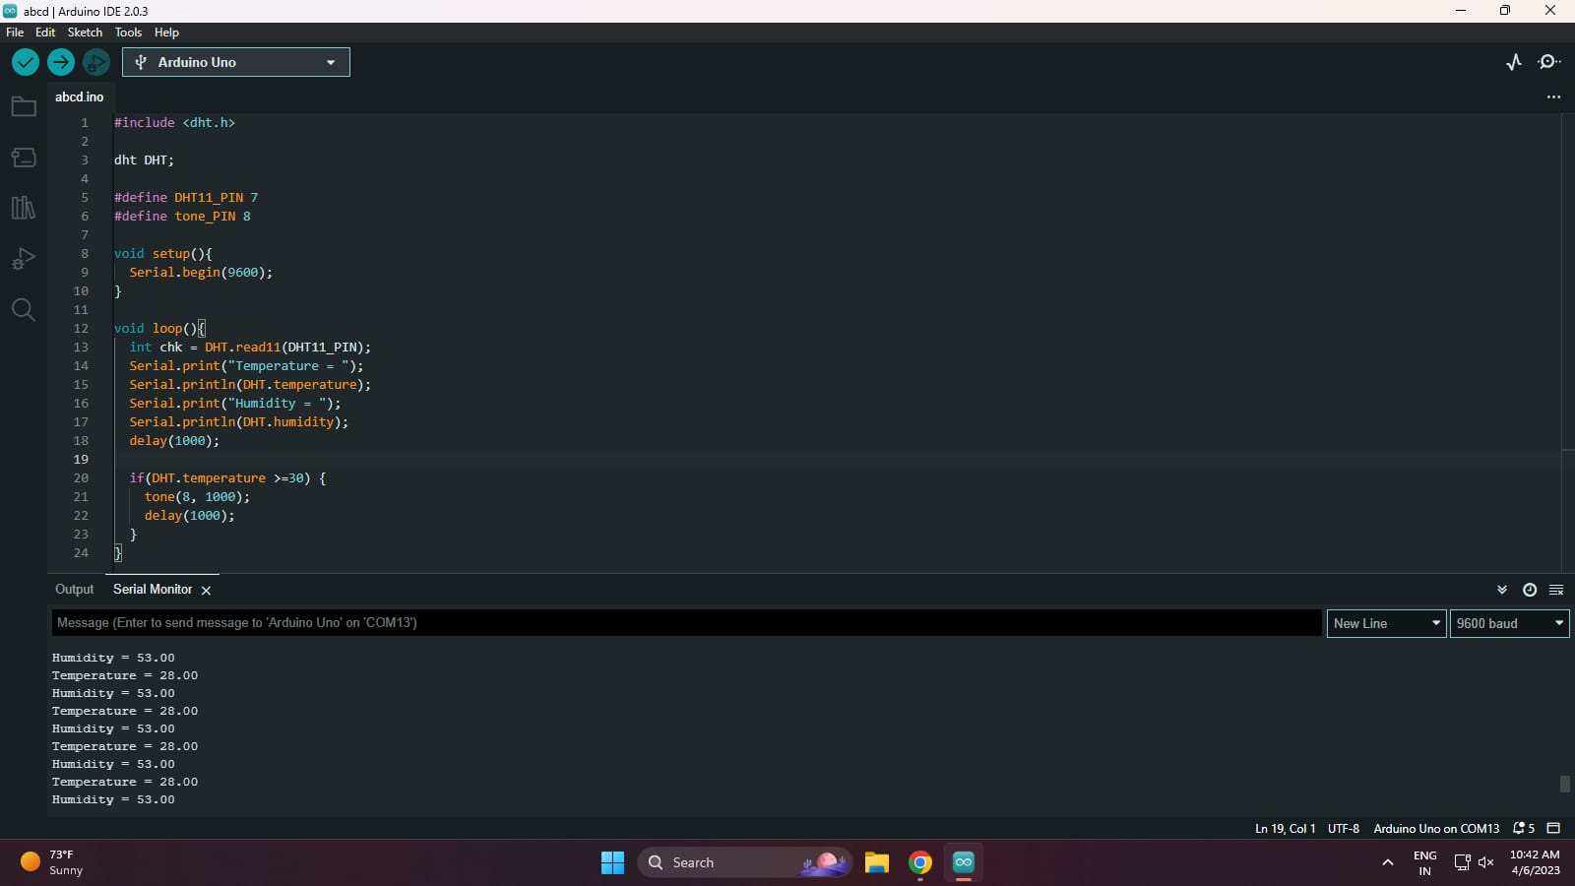

**FIGURE: Temperature and Humidity**

**Learning outcomes (What I have learnt):**

* Learnt how to use humidity sensor with real time application.
* Learnt how to code to read the data from the sensor.

**Evaluation Grid (To be created as per the SOP and Assessment guidelines by the faculty):**

|  |  |  |  |
| --- | --- | --- | --- |
| Sr. No. | Parameters | Marks Obtained | Maximum Marks |
| 1. |  |  |  |